Practical: 1 | Implementation and Time analysis of sorting algorithms. Bubble sort, Selection sort, Insertion sort, Merge sort and Quicksort
29/07/2026

Aim: To Implement and Time analysis of sorting algorithms. Bubble sort, Selection sort, Insertion sort, Merge sort and Quicksort.

1.Bubble sort

Algorithm:

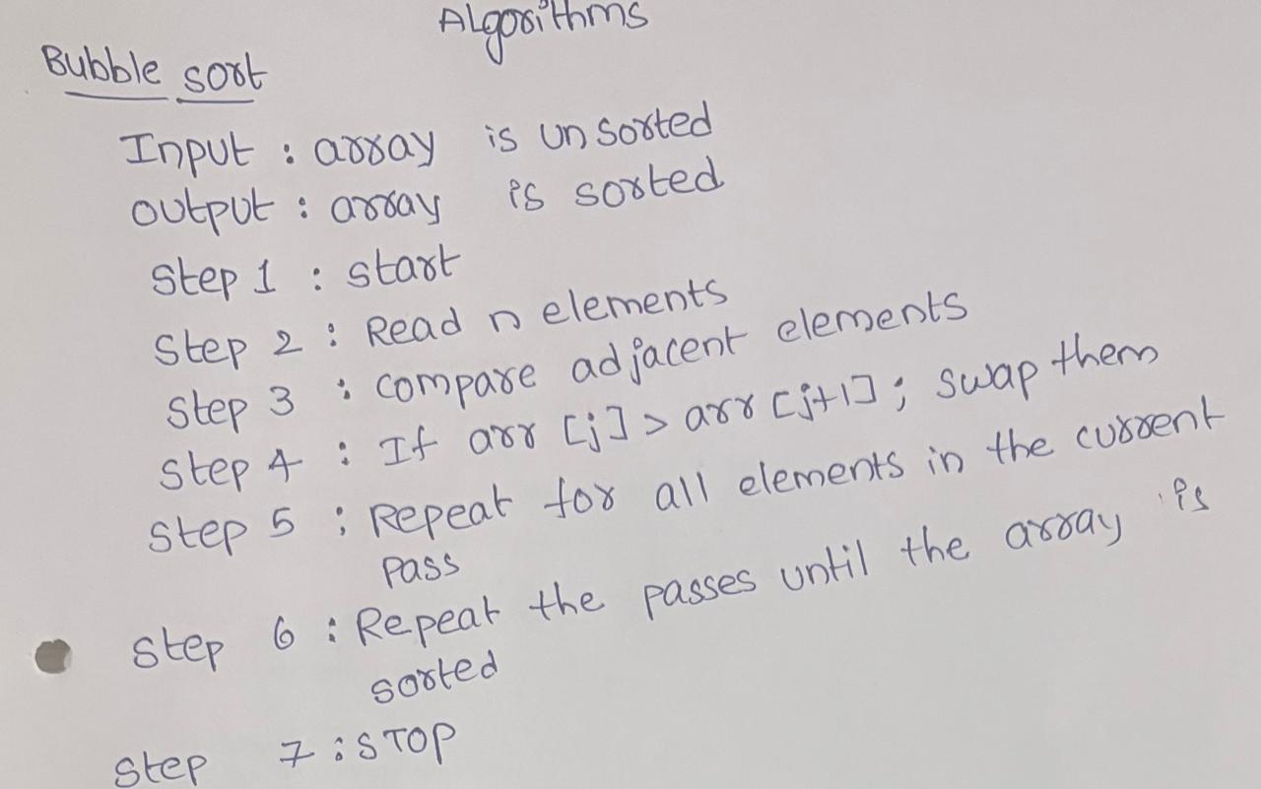

Program:

#include <iostream>
using namespace std;

class bubblesort
{
public:
int size;
int arr[100];
int i;

void arrayinput()
{
cout << "enter the size of array" << endl;
cin >> size;
cout << "enter the array elements" << endl;
for (i = 0; i < size; i++)
{
cin >> arr[i];
}
}

void printarray()
{
for (i = 0; i < size; i++)
{
cout << arr[i] << " ";
}
cout << endl;
}

void bubblelogic()
{
int i, j, temp;
for (i = 0; i < size - 1; i++)
{
for (j = 0; j < size - 1; j++)
{
if (arr[j] > arr[j + 1])
{
temp = arr[j];
arr[j] = arr[j + 1];
arr[j + 1] = temp;
}
}
}
}
};

int main()
{
bubblesort bs;
bs.arrayinput();
cout << "before sorting" << endl;
bs.printarray();
cout << "after sorting" << endl;
bs.bubblelogic();
bs.printarray();
return 0;
}
Output:
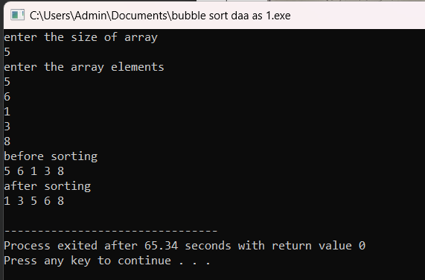

time Complexity:
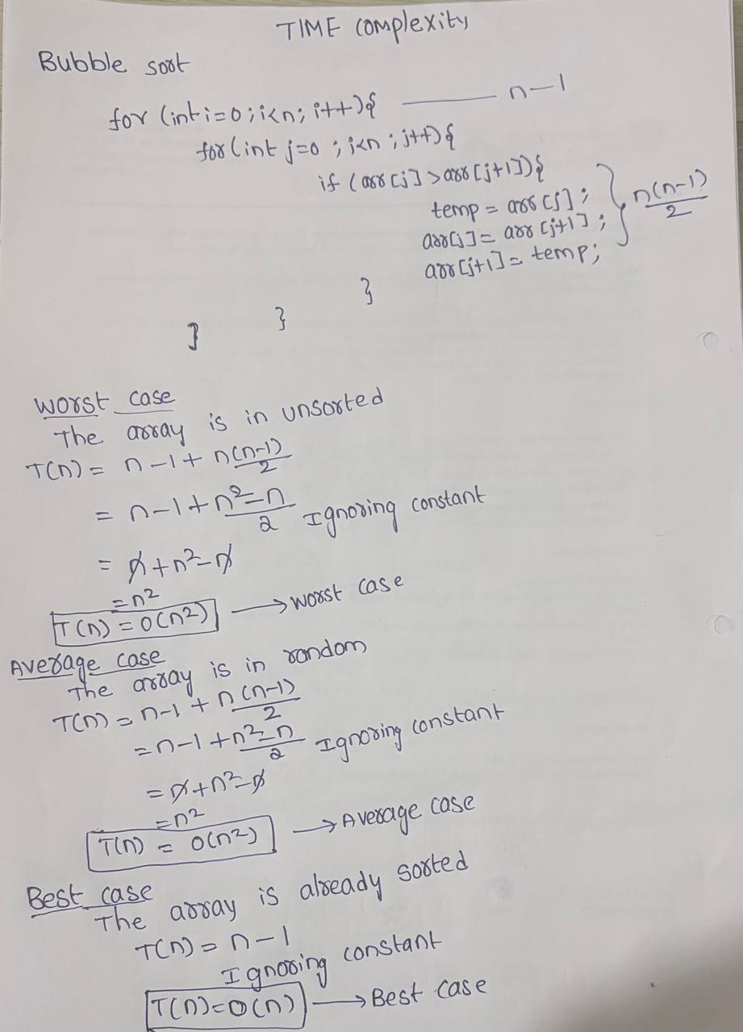

2.Selection sort
Alogrthim:
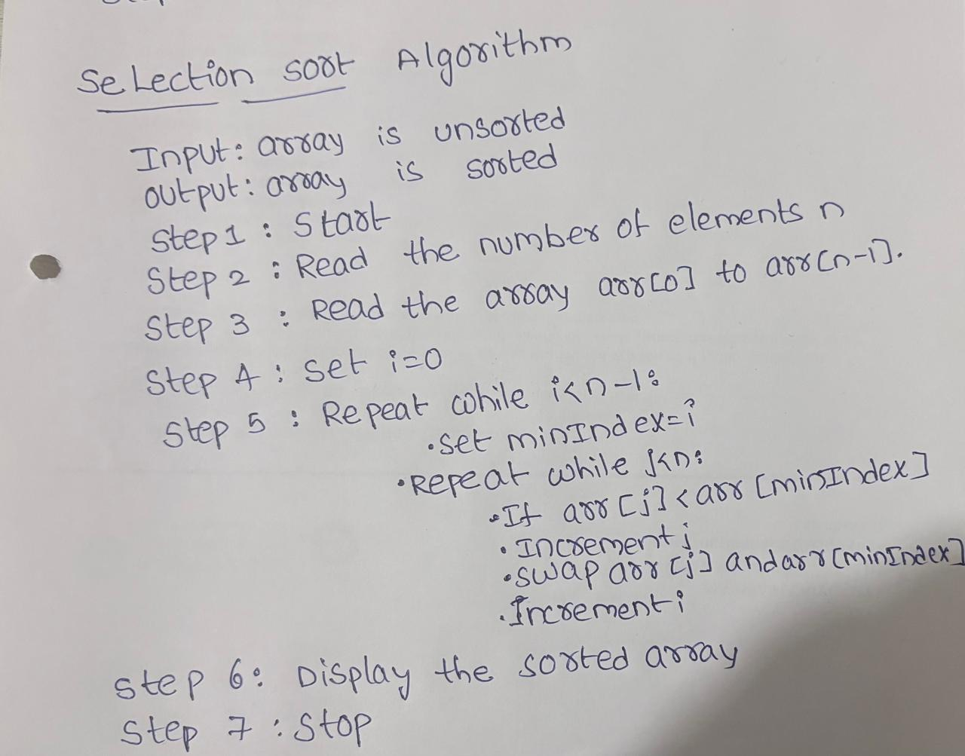

Program:
#include <iostream>
using namespace std;

class selectionsort
{
public:
int size;
int arr[100];
int i;

void arrayinput()
{
cout << "enter the size of array" << endl;
cin >> size;
cout << "enter the array elements" << endl;
for (i = 0; i < size; i++)
{
cin >> arr[i];
}
}

void printarray()
{
for (i = 0; i < size; i++)
{
cout << arr[i] << " ";
}
cout << endl;
}

void selectionlogic()
{
int i, j, minIndex, temp;
for (i = 0; i < size - 1; i++)
{
minIndex = i;
for (j = i + 1; j < size; j++)
{
if (arr[j] < arr[minIndex])
{
minIndex = j;
}
}
temp = arr[i];
arr[i] = arr[minIndex];
arr[minIndex] = temp;
}
}
};

int main()
{
selectionsort ss;
ss.arrayinput();
cout << "before sorting" << endl;
ss.printarray();
cout << "after sorting" << endl;
ss.selectionlogic();
ss.printarray();
return 0;
}
Output:
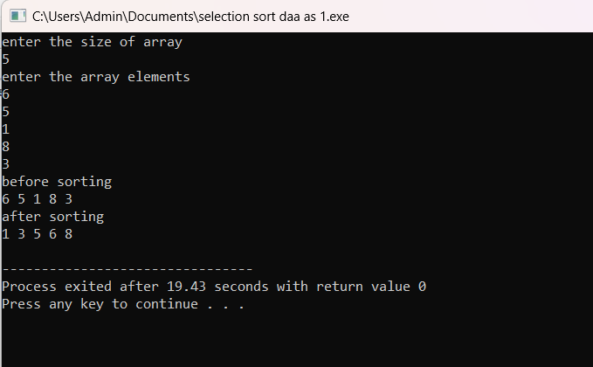

Time complexity:
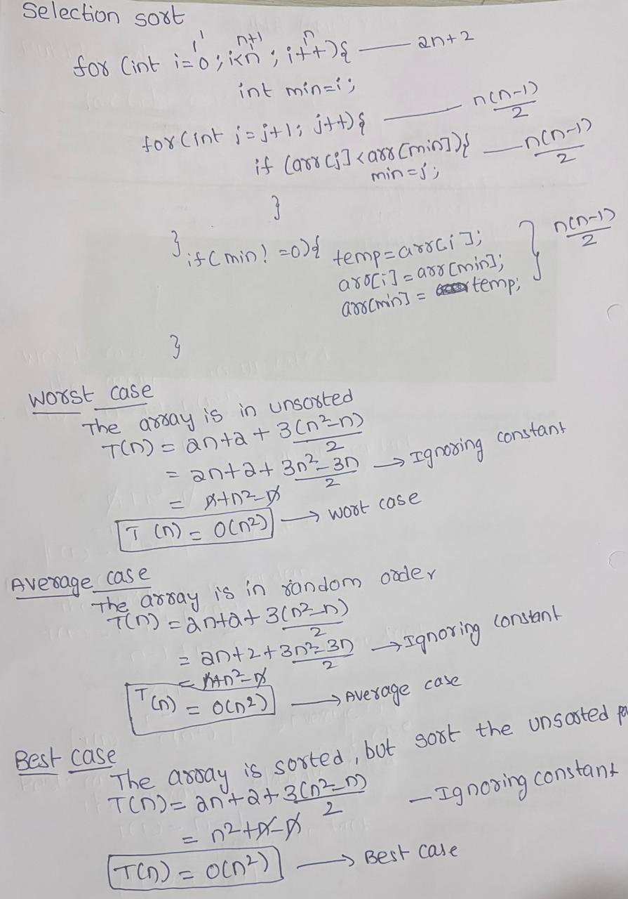

3.Insertion sort
Alogrthim:
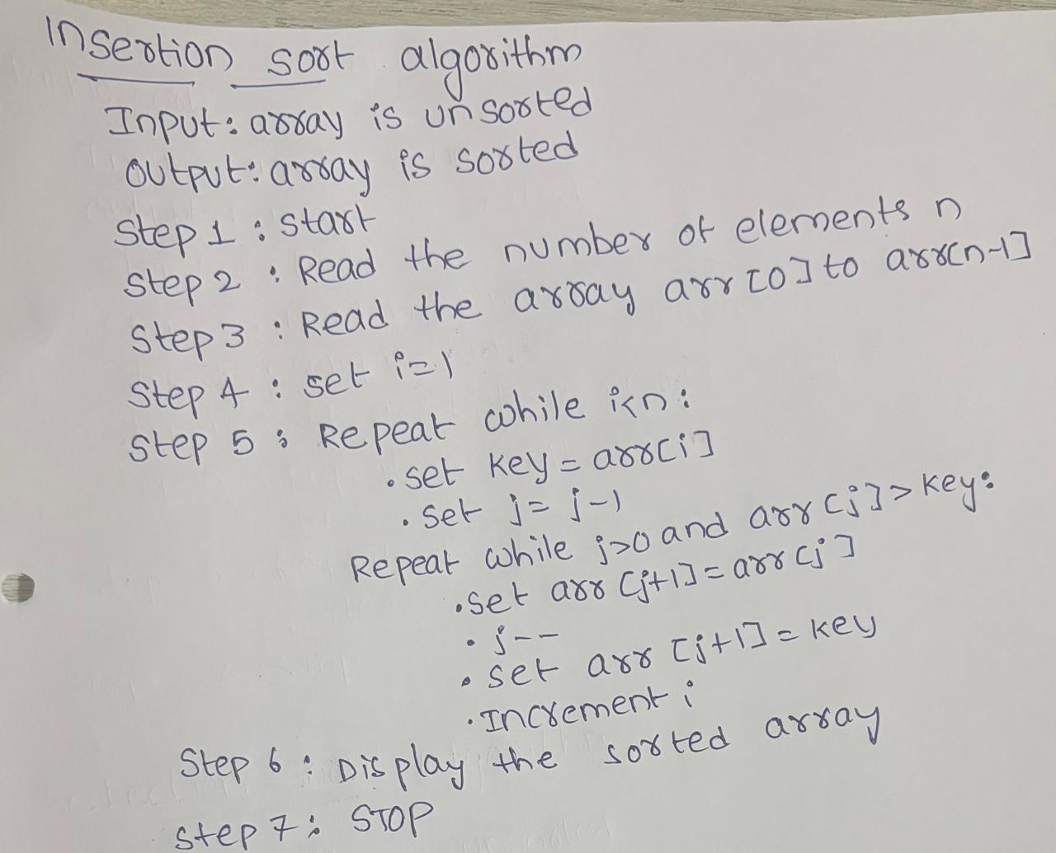
Program:
#include <iostream>
using namespace std;

class insertionsort
{
public:
int size;
int arr[100];
int i;

void arrayinput()
{
cout << "enter the size of array" << endl;
cin >> size;
cout << "enter the array elements" << endl;
for (i = 0; i < size; i++)
{
cin >> arr[i];
}
}

void printarray()
{
for (i = 0; i < size; i++)
{
cout << arr[i] << " ";
}
cout << endl;
}

void insertionlogic()
{
int i, j, key;
for (i = 1; i < size; i++)
{
key = arr[i];
j = i - 1;
while (j >= 0 && arr[j] > key)
{
arr[j + 1] = arr[j];
j = j - 1;
}
arr[j + 1] = key;
}
}
};

int main()
{
insertionsort is;
is.arrayinput();
cout << "before sorting" << endl;
is.printarray();
cout << "after sorting" << endl;
is.insertionlogic();
is.printarray();
return 0;
}
Output:
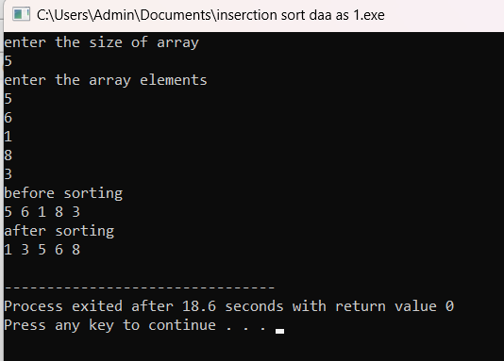

Time complexity:
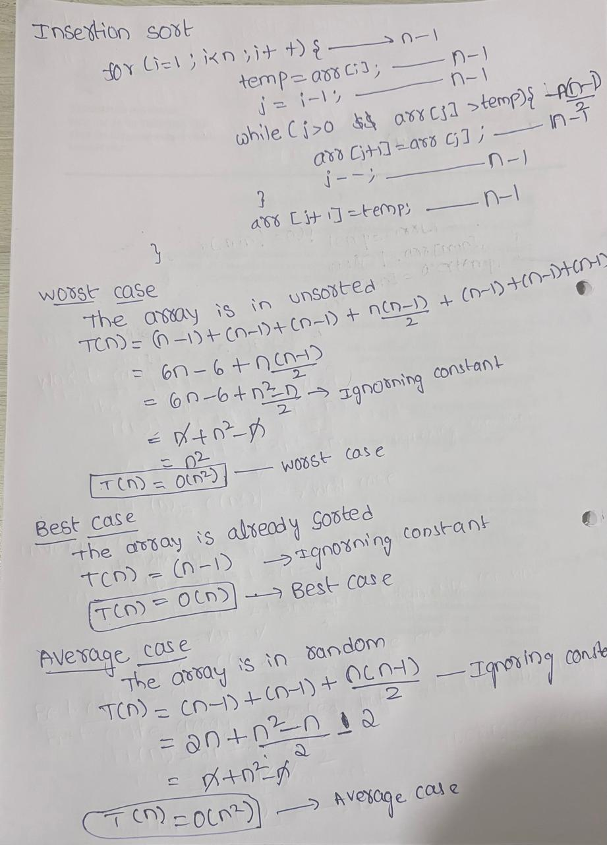

4.Merge sort
Algorthim:
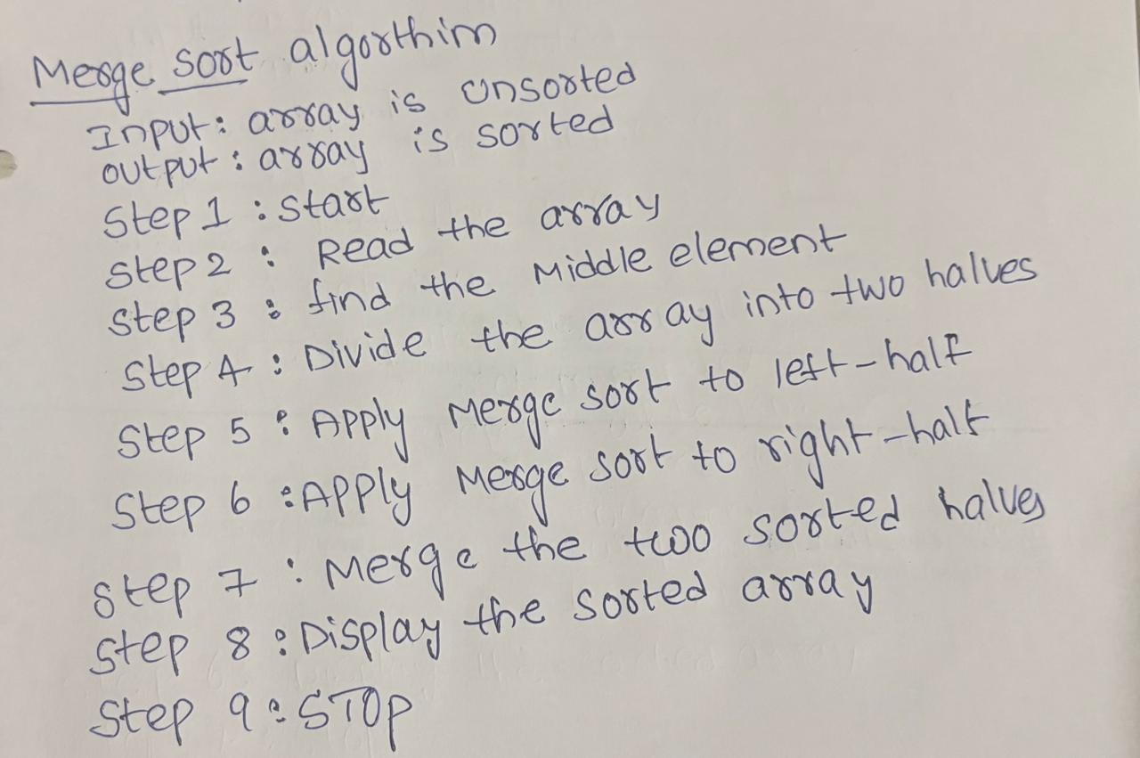

Program:
#include <iostream>
using namespace std;

class mergesort
{
public:
int size;
int arr[100];
int i;

void arrayinput()
{
cout << "enter the size of array" << endl;
cin >> size;
cout << "enter the array elements" << endl;
for (i = 0; i < size; i++)
{
cin >> arr[i];
}
}

void printarray()
{
for (i = 0; i < size; i++)
{
cout << arr[i] << " ";
}
cout << endl;
}

void merge(int low, int mid, int high)
{
int temp[100];
int i = low;
int j = mid + 1;
int k = low;

while (i <= mid && j <= high)
{
if (arr[i] <= arr[j])
{
temp[k] = arr[i];
i++;
}
else
{
temp[k] = arr[j];
j++;
}
k++;
}

while (i <= mid)
{
temp[k] = arr[i];
i++;
k++;
}

while (j <= high)
{
temp[k] = arr[j];
j++;
k++;
}

for (i = low; i <= high; i++)
{
arr[i] = temp[i];
}
}

void mergelogic(int low, int high)
{
if (low < high)
{
int mid = (low + high) / 2;
mergelogic(low, mid);
mergelogic(mid + 1, high);
merge(low, mid, high);
}
}
};

int main()
{
mergesort ms;
ms.arrayinput();
cout << "before sorting" << endl;
ms.printarray();
cout << "after sorting" << endl;
ms.mergelogic(0, ms.size - 1);
ms.printarray();
return 0;
}
Output:
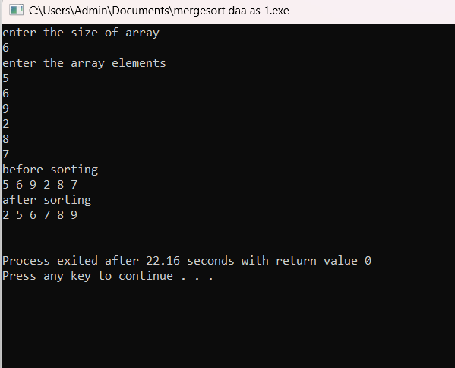

Time complexity:
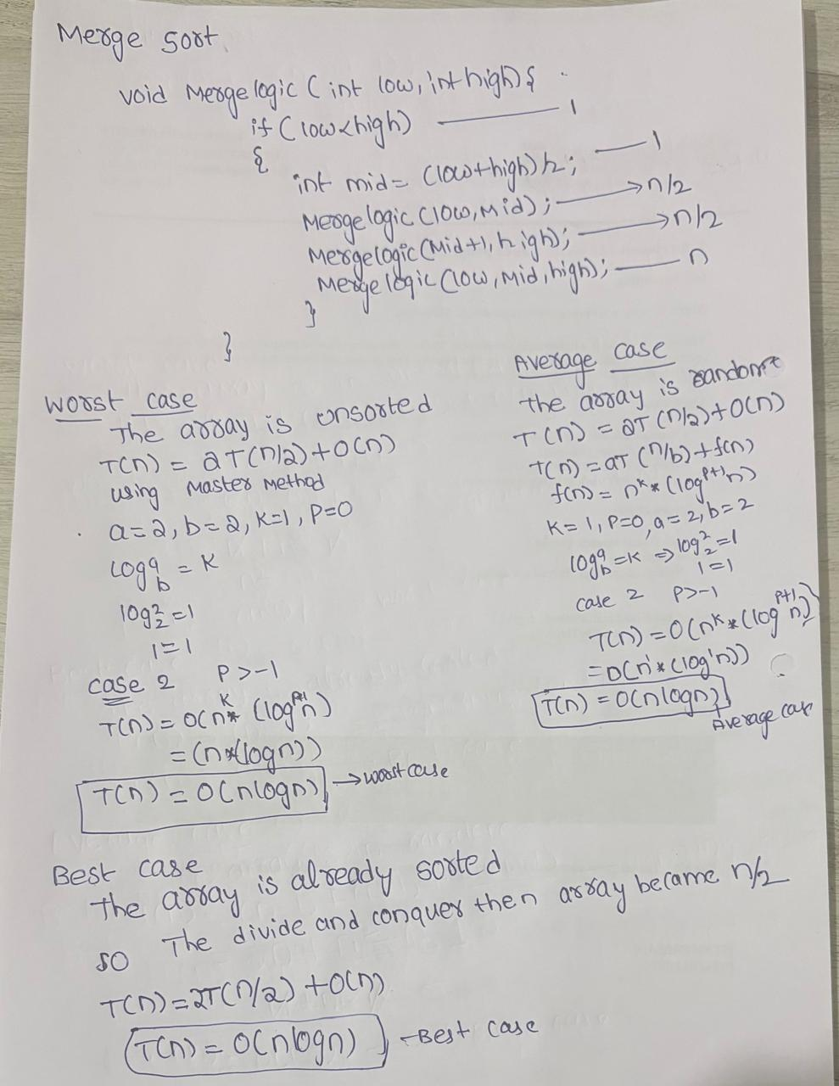

5.Quick sort
Algorthim:
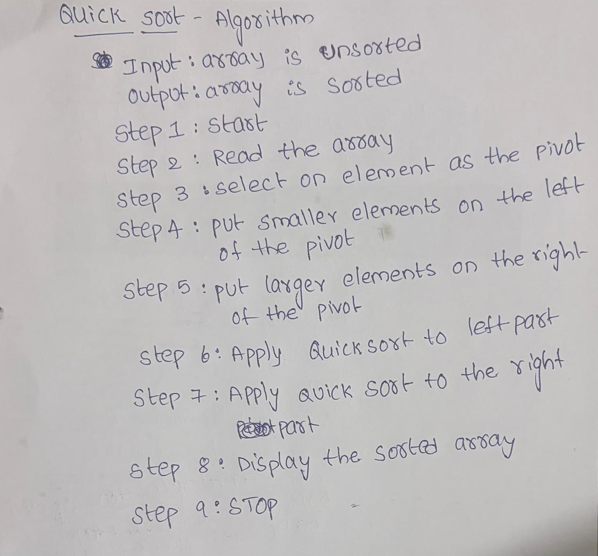

Program:
# <iostream>include
using namespace std;

class quicksort
{
public:
int size;
int arr[100];
int i;

void arrayinput()
{
cout << "enter the size of array" << endl;
cin >> size;
cout << "enter the array elements" << endl;
for (i = 0; i < size; i++)
{
cin >> arr[i];
}
}

void printarray()
{
for (i = 0; i < size; i++)
{
cout << arr[i] << " ";
}
cout << endl;
}

int partition(int low, int high)
{
int pivot = arr[high];
int i = low - 1;
int temp;

for (int j = low; j < high; j++)
{
if (arr[j] < pivot)
{
i++;
temp = arr[i];
arr[i] = arr[j];
arr[j] = temp;
}
}

temp = arr[i + 1];
arr[i + 1] = arr[high];
arr[high] = temp;

return i + 1;
}

void quicklogic(int low, int high)
{
if (low < high)
{
int pi = partition(low, high);
quicklogic(low, pi - 1);
quicklogic(pi + 1, high);
}
}
};

int main()
{
quicksort qs;
qs.arrayinput();
cout << "before sorting" << endl;
qs.printarray();
cout << "after sorting" << endl;
qs.quicklogic(0, qs.size - 1);
qs.printarray();
return 0;
}

Output:
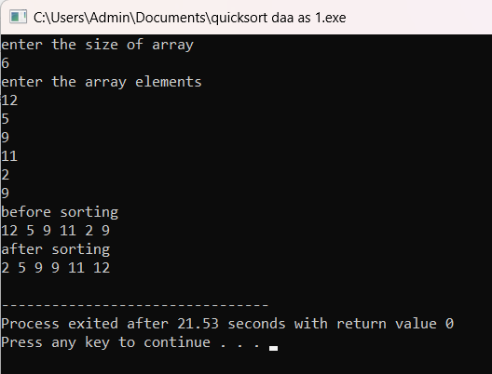
Time complexity: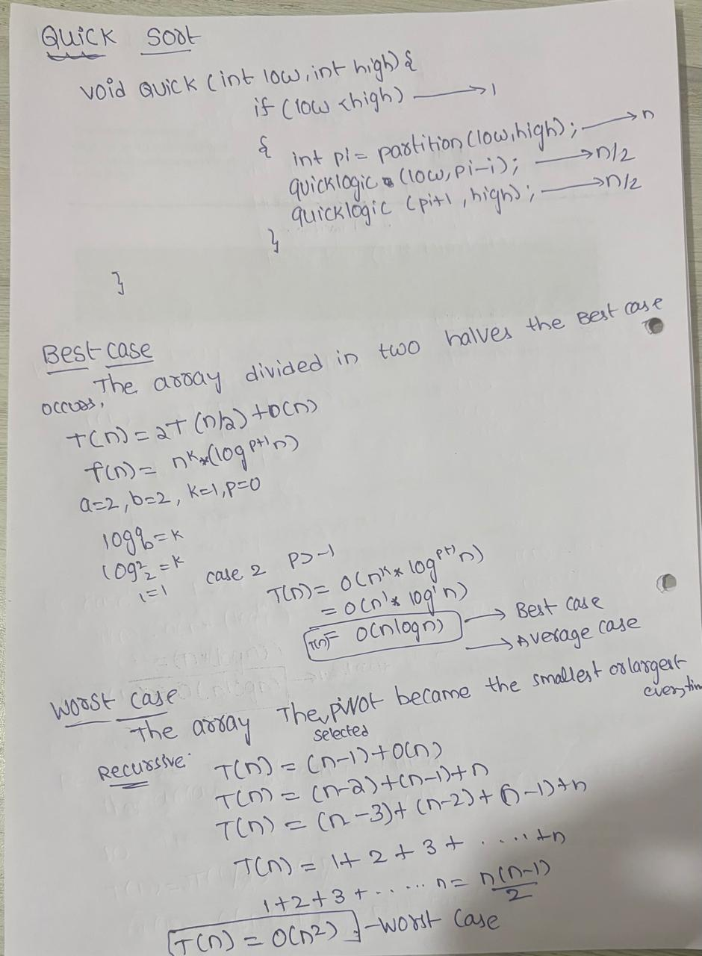

Conclusion:
In this practical, we implemented and studied five sorting algorithms: Bubble Sort, Selection Sort, Insertion Sort, Merge Sort, and Quick Sort. We learned how each algorithm works and compared their time complexities.
Bubble Sort, Selection Sort, and Insertion Sort are simple but can be slow for large data. Merge Sort and Quick Sort are generally faster and more suitable for large datasets. Therefore, the choice of sorting algorithm depends on the size and type of data.

